Experiment 13: Creating and Allocating a Virtual Hard Disk
Aim
To create a Virtual Hard Disk and allocate storage using VirtualBox.
Steps
- Open VirtualBox → Click New or Settings → Storage.
- Choose Create a new virtual hard disk.
- Select VDI as disk file type.
- Choose Dynamically Allocated or Fixed Size.
- Allocate the required disk size (15GB).
- Attach the virtual disk to the VM.
- Save the configuration.
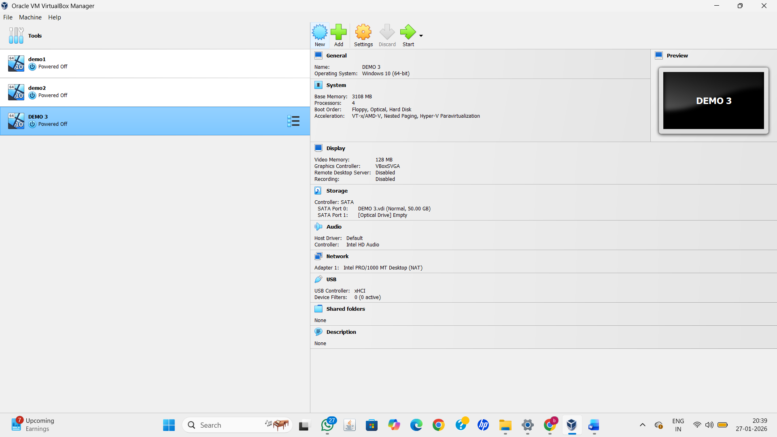
Result
A Virtual Hard Disk was successfully created and allocated to the Virtual Machine.

